🧾 README – TYNDP Scenario Data Package
1. Purpose of this repository
This repository contains the results from the TYNDP 2026 scenario market model.
It is intended to help users navigate and understand where to find specific data categories.
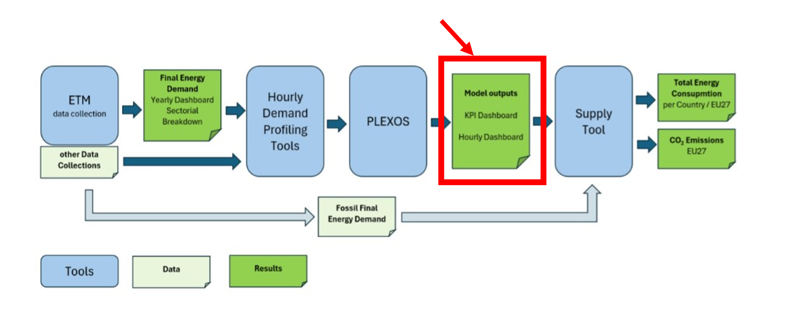
Figure 1: Data flow in TYNDP 2026 Scenario Toolchain
👉 For methodology and assumptions, please refer to the official Scenario Building Methodology Report.
This README only provides a data map, not a methodological explanation.
2. Scenarios
The dashboards contain results from 3 different runs:
- NT+: Central Scenario, reflecting the latest national strategies, updated National Energy and Climate Plans (NECPs), and EU policies. Those runs also include adequacy units (SoS).
- HEV: The HEV represents a higher Gross Domestic Product (GDP) growth than NECPs indicate, including higher sectorial activity, purchasing power or willingness to pay, stronger focus on innovation and risky investments, and a stronger focus on sustainability as well as long-term views on investment decisions.
- LEV: The LEV represents a lower GDP than NECPs indicate. It includes a more moderate or less sectorial activity, purchasing power or spending opportunities, less focus on innovation, and a more business-as-usual approach. It involves stronger focus on cost and affordability, and a short-term view on investment decisions.
2. KPI Dashboards
The dashboards present the key market modelling results for electricity, hydrogen, heat, CO₂, and (e-)fuels. They are structured into individual sheets for each country, as well as a dedicated sheet providing aggregated values for EU27.
An additional “Info” sheet explains the KPIs used throughout the dashboards.
Each sheet includes data for all target years, with three climate scenarios per year, as well as a corresponding weighted average. For the weighing factors please see the chapter on weather year selection in the methodology report.
The KPIs are grouped into several sections:
- Installed Capacity [GW] - The total available generation capacity installed for each technology. Those are input values into the model.
- Generation [TWh] - The total amount of energy produced by the given technology. Most values are model outcomes, except for the heat production of H2 and CH4 Hybrid Heat Pumps.
- FLH [h] - Full Load Hours. The number of hours a plant would need to run at full capacity to produce its total annual generation. Full Load Hours are calculated as the Generation divided by the installed Capacity of that technology.
- Exchange [TWh] - The amount of electricity, hydrogen and e-fuels imported or exported between countries.
- Consumption [TWh] - Demand of the different energy carriers.
- Prices [€/MWh] - Load-weighted market prices for electricity and hydrogen, including 10% and 90% quantiles.
- Import Share [%] - The proportion of total energy supply that is met through imports.
- Energy Balance [TWh] - Summary of all energy entering the system (generation and imports) and all energy leaving the system (consumption and exports), resulting in a net balance of zero. There is a balance for electricity and one for hydrogen. This balance is derived from the other KPIs in the dashboard. More details about the KPIs used in the calculation can be found in the Info Sheet.
Please note that for some countries there are behind the meter PV and battery capacities which are not reported in the KPI Dashboards as they were not modeled in Plexos. For details, see the Methodology Report and the BTM folder in the Inputs part of this Data Package.
3. Hourly Dashboards
The hourly dashboards contain the timeseries data from the modelling results. There is a subfolder for every Weather Scenario for each of the scenarios, NT+, LEV and HEV. The structure is visualised in Figure 1. Every subfolder contains 39 excel sheets, one for each country.
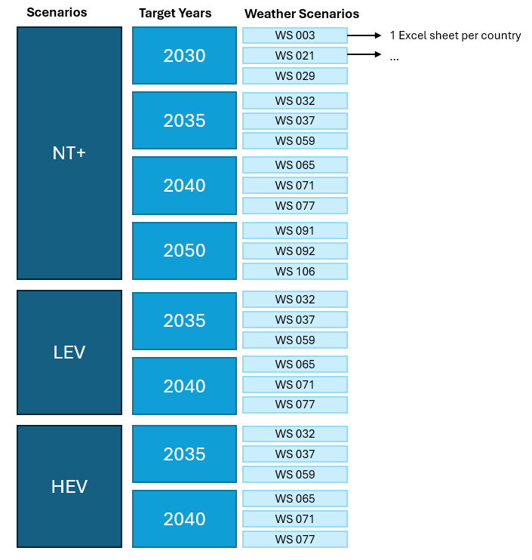
Figure 2: Folder structure of the hourly result dashboards
The sheets are organised according to the model topology (see Figure 3), with the following sheet structure:
- E-Market: Electricity generation, load, balance and prices in the E-Market Node
- Prosumer: Electricity generation, load, balance and prices in the Prosumer Node
- H2 Zone 2: Hydrogen generation, load, balance and prices in the H2 Zone 2 Node
- H2 Zone 1: Hydrogen generation, load, balance and prices in the H2 Zone 1 Node
- Heat H2: Heat production and demand by H2 boilers and heat pumps
- Heat CH4: Heat production and demand by CH4 boilers and heat pumps
- Synfuels_EU27: Domestic production, imports and demand for synfuels. Including CO2 used for synfuel production. Only data on EU27 level.
- Exchanges: Exchanges between different nodes such as
  - Between E-Market nodes of different countries
  - Between E-Market and prosumer nodes
  - Between E-Market and H2 Zone 2 nodes (Electrolyzers)
  - Between H2 Zone 2 nodes of different countries
  - Between H2 Zone 2 and Zone 1
  - Between SRES node and H2 Zone 2 node
  - Between DRES and H2 Zone 2 node
  - Imports into the H2 Zone 2 node
  - H2 used as a fuel for H2 power plants
  - Between H2 Zone 2 and E-Fuel nodes
  - Between CO2 and E-Fuel nodes
  - Between E-Fuel nodes
- Installed Capacity: Installed capacities of generation and storage units appearing in the timeseries
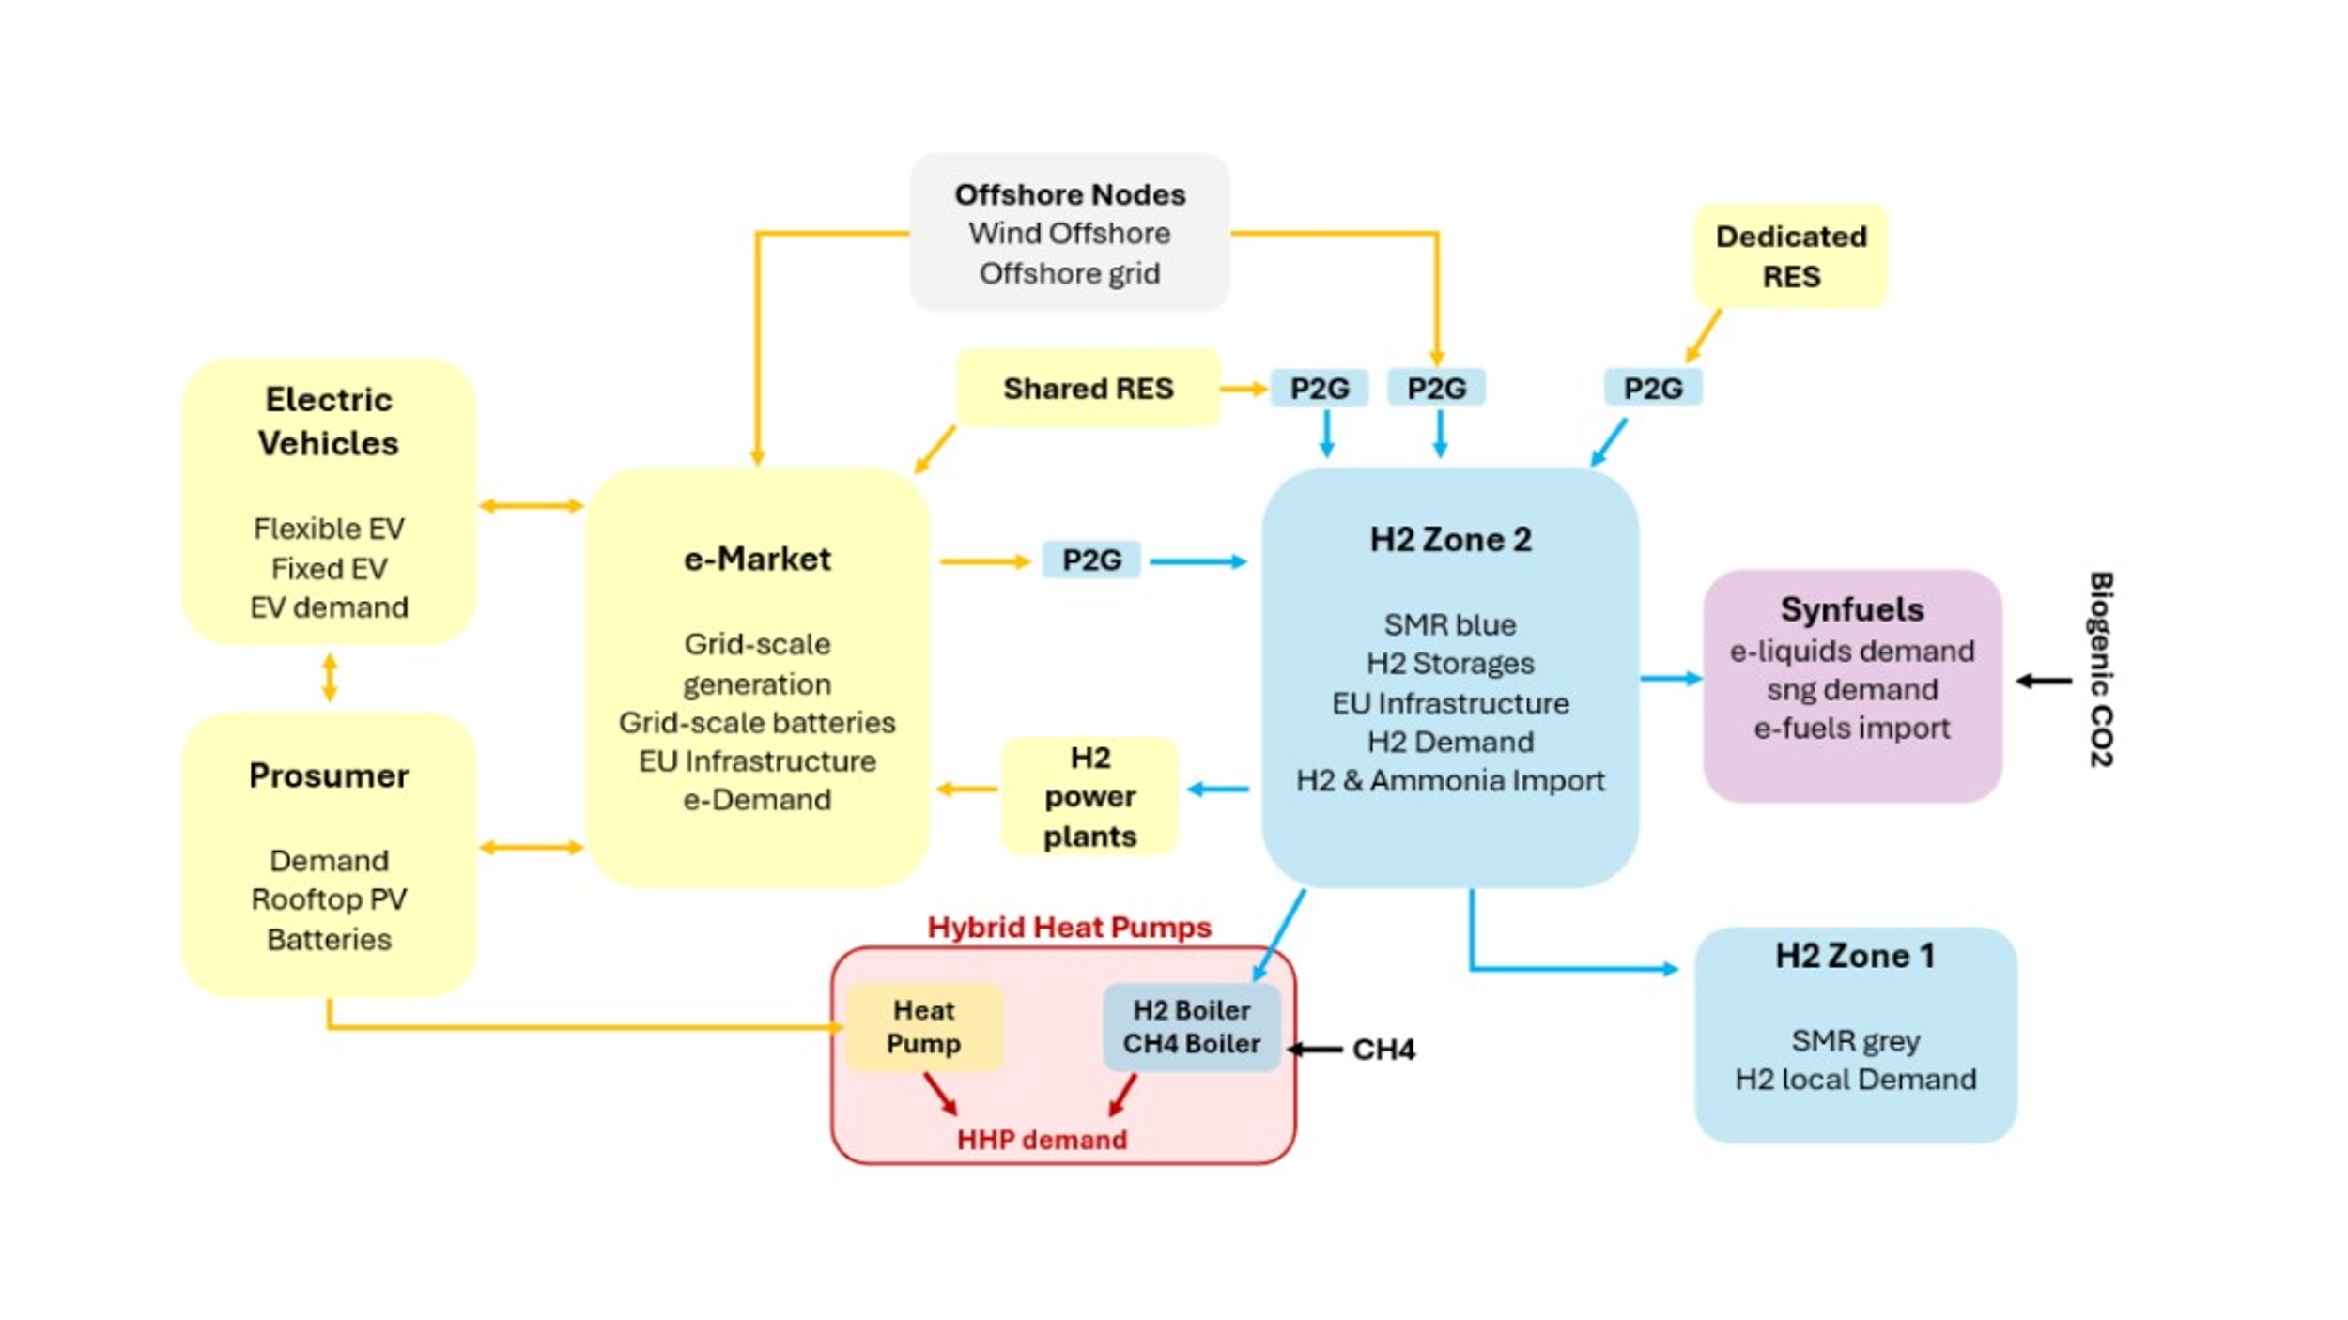
Figure 3: Model topology
Each sheet contains (some of) those elements:
- Generation per technology type
- Storage charging and discharging (if applicable)
- Demand
- Dump Energy (if applicable)
- Balance: Generation – Load
- Energy Not Served (if applicable)
- Marginal Cost or Price (if applicable)
Some special cases:
- Electrolyzers: Timeseries for electrolyzers appear in the E-Market, the Zone 2 and Exchanges sheet. The E-Market and Exchanges sheet display the energy used by the electrolyzers in MW_e, while the Zone 2 Sheet shows the production of hydrogen by the electrolyzers in MW_H2.

